# CSS

**Problem Statement 1:** Design a web page to display drop cap effect.

**Objective:** To create a visually appealing web page that demonstrates the use of CSS to apply a drop cap effect to the first letter of a paragraph. This exercise aims to enhance the understanding of CSS pseudo-elements and their practical applications in web design.

# Code:

<!DOCTYPE html>

<html lang="en">

<head>

<style>

p::first-letter{ float: left;

font-size: 30px;

}

</style>

<title>capdown</title>

</head>

<body>

<p>Lorem ipsum dolor sit amet consectetur adipisicing elit. Nulla temporibus nostrum impedit dolore laborum quas aspernatur facere, excepturi rerum recusandae! Lorem ipsum, dolor sit amet consectetur adipisicing elit. Deleniti sunt provident modi impedit consequuntur, tenetur nisi nam nobis earum cum?Lorem ipsum dolor sit amet consectetur adipisicing elit. Est veritatis quia tempora earum illo, qui provident explicabo voluptas unde nesciunt omnis consequatur fugit? Nihil ipsum asperiores eum, ipsa exercitationem, inventore enim necessitatibus perspiciatis ea dolorem numquam eos voluptates! Iusto accusantium similique adipisci atque voluptatibus commodi doloribus, corrupti quasi ducimus itaque modi magnam deleniti repellat necessitatibus, aspernatur alias repudiandae. Tempore molestiae consequuntur excepturi optio cum, dolorum qui voluptatem recusandae assumenda, ratione at repudiandae atque ex! Ipsa perferendis earum eligendi impedit eaque quo architecto non fugit cum repellat dolorem aut illum sed odio, eum voluptates maxime, dolores obcaecati, delectus possimus! Eos, laudantium.</p>

</body>

</html>

# Output:

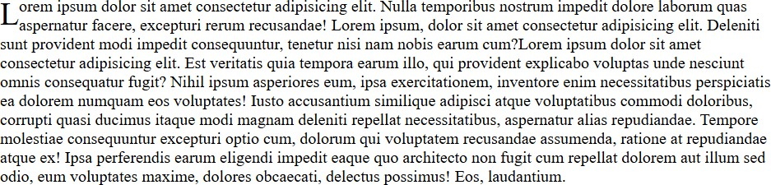

**Problem Statement 2:** Design a web page to display watermark effect.

**Objective:** To create a web page that demonstrates the use of CSS to apply a watermark effect to images. This exercise aims to enhance the understanding of CSS pseudo-elements and their practical applications in web design.

# Code:

Html

<!DOCTYPE html>

<html>

<head>

<title>Image Gallery</title>

<link rel="stylesheet" href="style.css">

</head>

<body>

<div class="img-container">

<h3>Image gallery</h3>

<div class="img-box" watermark="true">

<img src="./images/img1.jpg" alt="">

</div>

<div class="img-box" watermark="true">

<img src="./images/img2.jpg" alt="">

</div>

<div class="img-box" watermark="true">

<img src="./images/img3.jpg" alt="">

</div>

</div>

</body>

</html>

CSS

body{

display: flex;

align-items: center; justify-content: center; height: 100vh;

background-color: #040712; font-family: sans-serif;

}

.img-box{

aspect-ratio: 1/.6; width: 200px; overflow: hidden; opacity: .5; transition: .3s ease; position: relative;

}

.img-box:hover{ opacity: 1; transform: scale(1.1); cursor: pointer;

border: 2px solid white;

}

.img-box[watermark="true"]::before{ content: 'watermark';

font-weight: 600; font-size: 32px; position: absolute; top: 0;

left: 0;

width: 100%;

height: 100%;

color: rgba(0, 0, 0, 0.5); display: flex;

align-items: center; justify-content: center;

}

img{

width: 100%;

height: 100%; object-fit: cover;

}

.img-container{ padding: 10px; gap: 16px; display: flex; position: relative;

}

h3{

color: #e7f0f1;

text-transform: capitalize; white-space: nowrap; position: absolute;

top: -50px;

}

# Output:

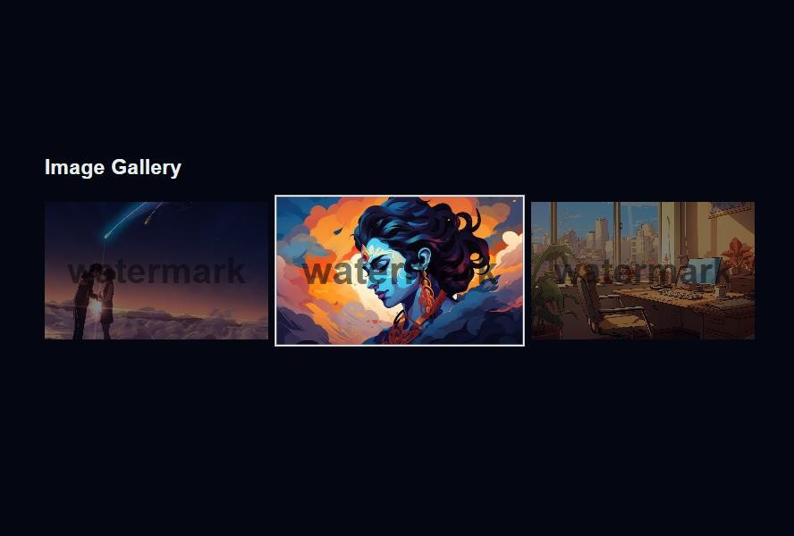

**Problem Statement 3:** Design a web page to display the given format

**Objective:** To design a visually appealing landing page that effectively captures the user's attention and provides a clear and engaging introduction to the websites.

# Code:

Html

<!DOCTYPE html>

<html>

<head>

<title>Web Design</title>

<link rel="stylesheet" href="./index.css">

</head>

<body>

<nav>

<div id="logo">Logo</div>

<div class="right">

<ul>

<li>Home</li>

<li>About Us</li>

<li>Projects</li>

</ul>

<button class="btn">Get Started</button>

</div>

</nav>

<section>

<div class="left">

<h1>Website Design Services</h1>

<p>Lorem ipsum dolor sit amet, consectetur adipisicing elit. Expedita nobis facere nisi similique ullam incidunt omnis placeat delectus. Nemo, provident?</p>

<button class="btn">Learn More</button>

</div>

<div class="right">

<img src="./banner.jpg" alt="banner">

</div>

</section>

</body>

</html>

CSS

*{

font-family: sans-serif; list-style: none; margin: 0;

padding: 0;

}

nav{

display:flex;

justify-content: space-between; padding: 16px;

align-items: center;

}

nav ul{

display: flex; gap: 20px;

align-items: center;

}

nav .right{ display:flex; gap:20px;

}

nav .right .btn{ background:#FF85A2;

}

#logo{

color: #FF85A2; font-size: 28px; font-weight:700;

}

section{

display: flex; gap: 20px;

}

section .left, section .right{

flex: 1;

}

section .left{ padding:16px; margin: auto;

}

section h1{

font-size: 42px; margin-bottom: 16px; color:#242fb4;

font-weight: 800;

}

section p{ color:#3b3b3b; margin-bottom: 18px;

}

.btn{

padding:10px 18px; border-radius: 50px; font-weight: 600; color:white; background: #7882fb;

border: 2px solid #3c40a5;

box-shadow: 4px 4px 5px rgba(0, 0, 0, 0.349);

}

section .right img{ width: 100%;

height: 100%; object-fit: contain;

}

# Output:

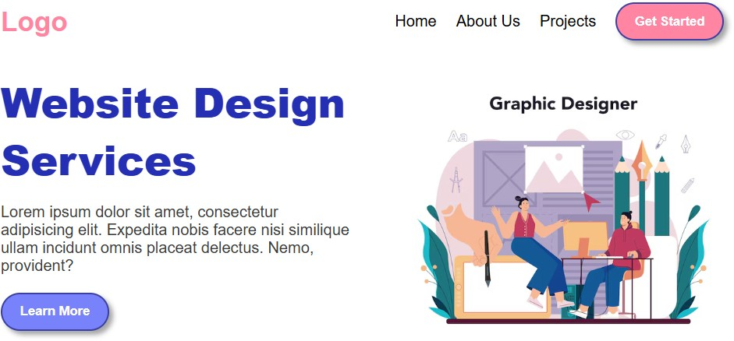

**Code**

<!DOCTYPE html>

<html>

<head>

<meta charset="UTF-8">

html

<meta name="viewport" content="width=device-width, initial-scale=1.0">

<title>webpage 2</title>

<link rel="stylesheet" href="style.css">

</head>

<body>

<nav>

<div class="container flex justify-between">

<div id="logo" class="flex items-center"> logo

</div>

<div class="search-box flex">

<input type="text" placeholder="search for domain">

<img src="./search-icon.svg" alt="" class="icon">

</div>

<div class="flex btn-wrapper">

<button class="secondary">log in</button>

<button>create a site</button>

</div>

</div>

</nav>

<div class="container">

<section class="flex">

<div class="left">

<img src="./img.png" alt="">

</div>

<div class="right">

<h2>Make it <span>fresh.</span></h2>

<p>Make your own website.</p>

<div class="flex btn-wrapper">

<button>create a site</button>

<button class="secondary">learn more</button>

</div>

</div>

</section>

</div>

</body>

</html>

CSS

*{

margin: 0;

padding: 0;

box-sizing: border-box; font-family: sans-serif; list-style: none;

user-select: none;

text-decoration: none;

}

body{

background-color: #6f8ea0; color: white;

min-width: 100svh; overflow: hidden;

}

.container{

max-width: 1200px; margin: auto;

}

.icon{

width: 24px; aspect-ratio: 1;

}

.flex{

display: flex;

}

.items-center{

align-items: center;

}

.justify-between{

justify-content: space-between;

}

nav{

width: 100%; display: flex;

align-items: center;

justify-content: space-between; padding: 10px;

background-color: rgba(0, 0, 0, 0.103); position: fixed;

left: 0;

right: 0;

}

nav .container{

width: 100%;

}

nav #logo{

font-weight: 600; font-size: 24px;

}

.search-box{

border-bottom: 1px solid white; padding: 0 8px;

}

.search-box input{

background-color: transparent; outline: none;

border: none; color: white;

}

.search-box input::placeholder{ color: white;

}

.btn-wrapper{ gap: 8px;

}

button{

padding: 8px 16px; color: black;

text-transform: uppercase; font-weight: 600;

cursor: pointer; background-color: white; outline: none;

border: none; transition: .3s;

}

button:hover{

transform: scale(1.05); filter: brightness(90%);

}

button.secondary{

background-color: transparent; color: white;

}

button.secondary:hover{ color: #acbfcc;

}

section {

height: 100svh;

}

section .left img{ width: 100%;

height: 100%; object-fit: contain;

}

section .left{ flex: 1;

}

section .right{ margin: auto; flex: 1;

}

section .right h2{

font-size: 48px; font-weight: 500;

}

section .right h2 span{ color: #acbfcc;

}

section .right p{ font-size: 18px; margin: 16px 0; color: #acbfcc;

}

# Output:

